using any Cloud Service Provider to demonstrate SaaS include the necessary fields such as name of the students, course, present, Absent, course attendance, OD request, grade, attendance percentage, etc.

Step 1: - Go to ZOHO.com

Step 2: - Create and account and log into the account

Step 3: - Create an application

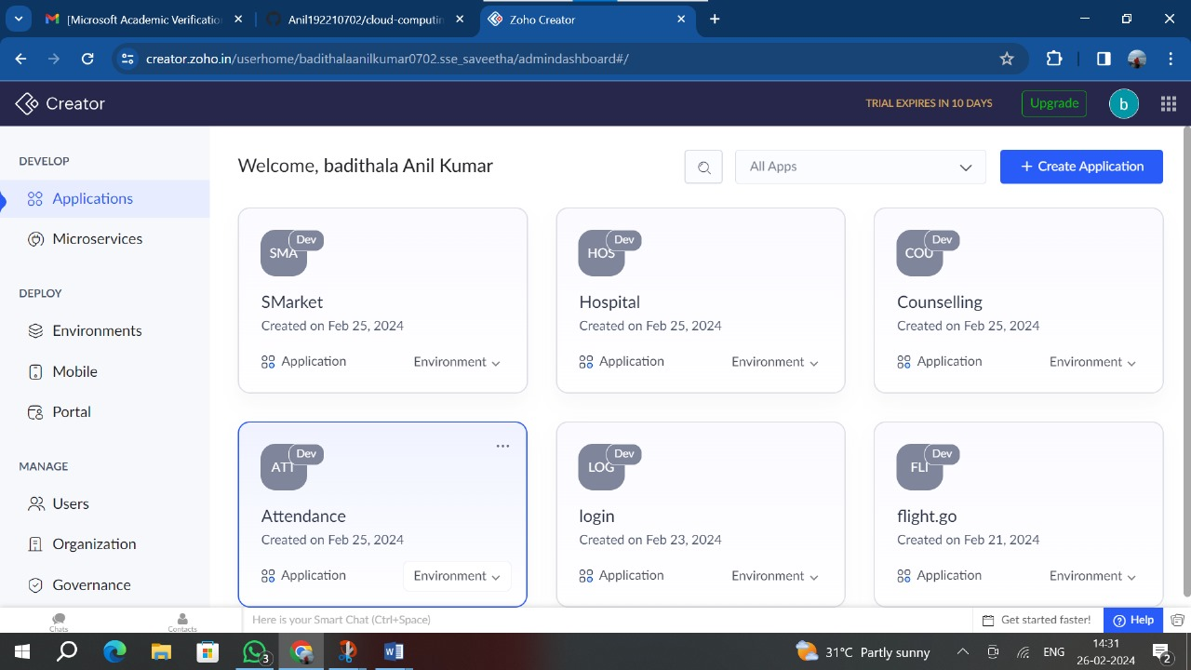

Step 4: - Create login form

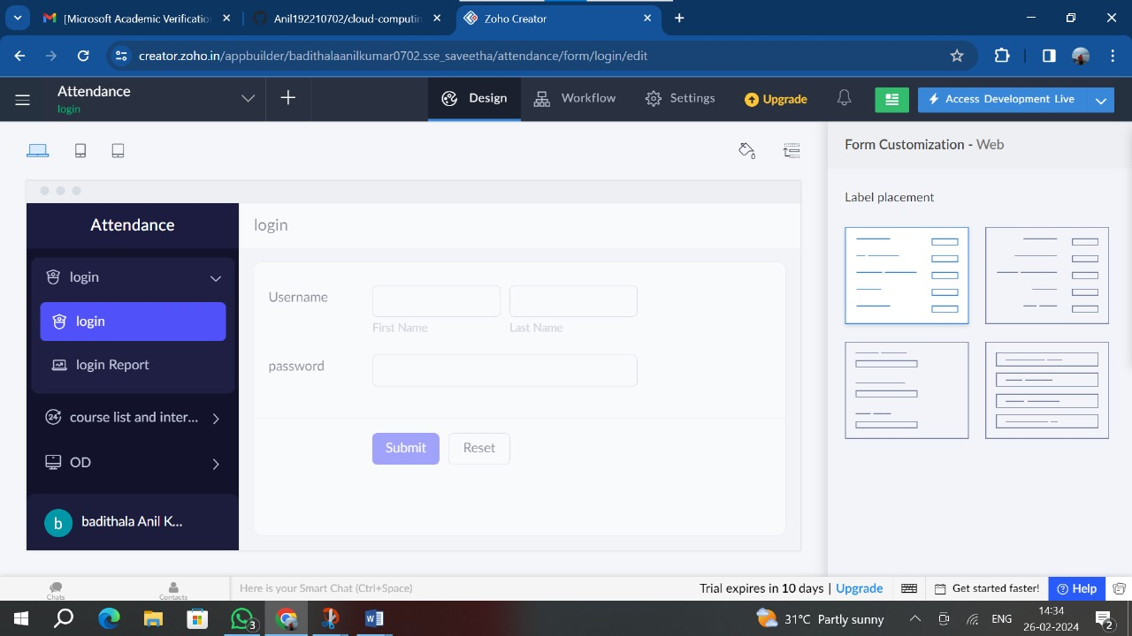

Step 5: - Create a form for course details

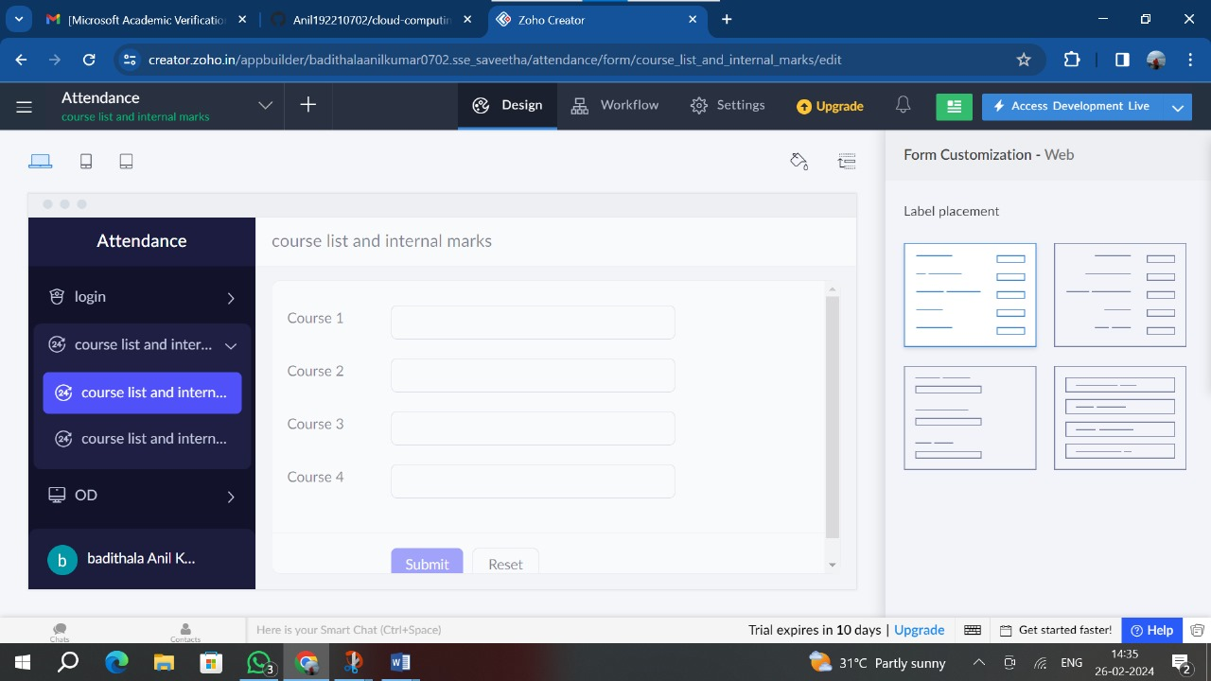

Step 6: - Create a form for OD request

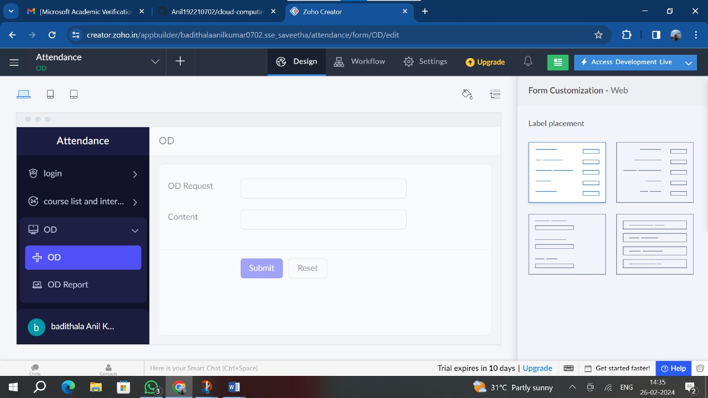

Step 7: - Create a form for results

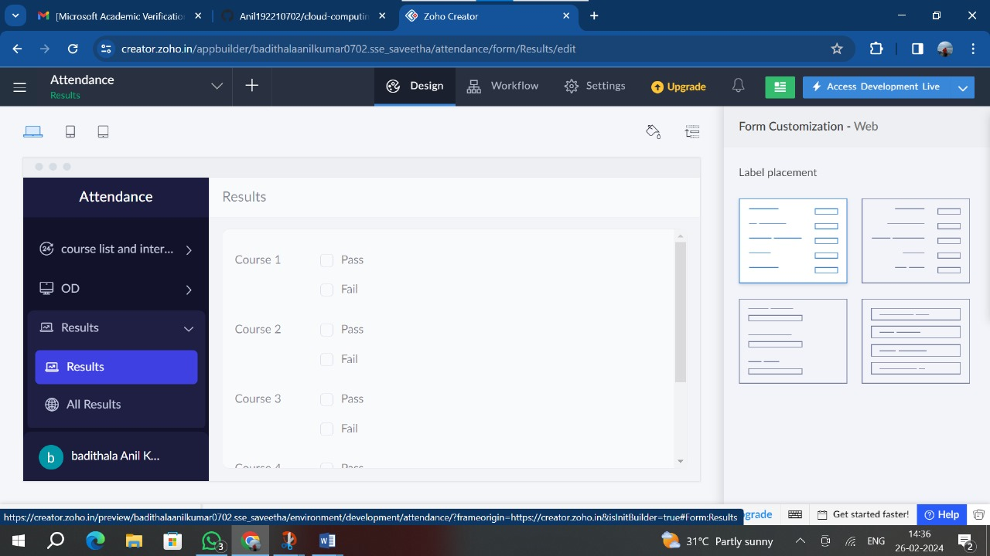

Step 8: - Click on the Access development live to view the output

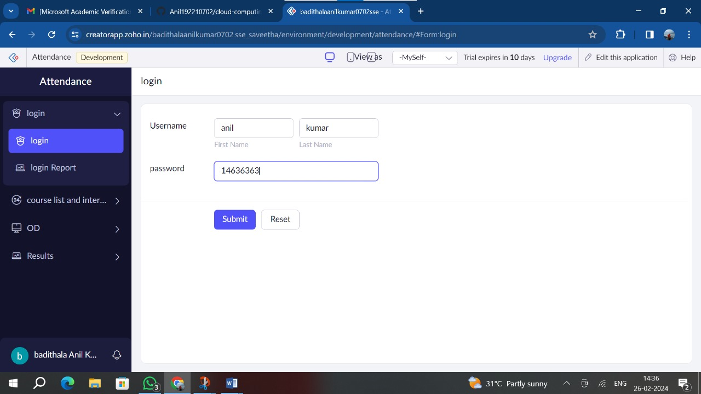

Step 9: Click on the report to see the saved data

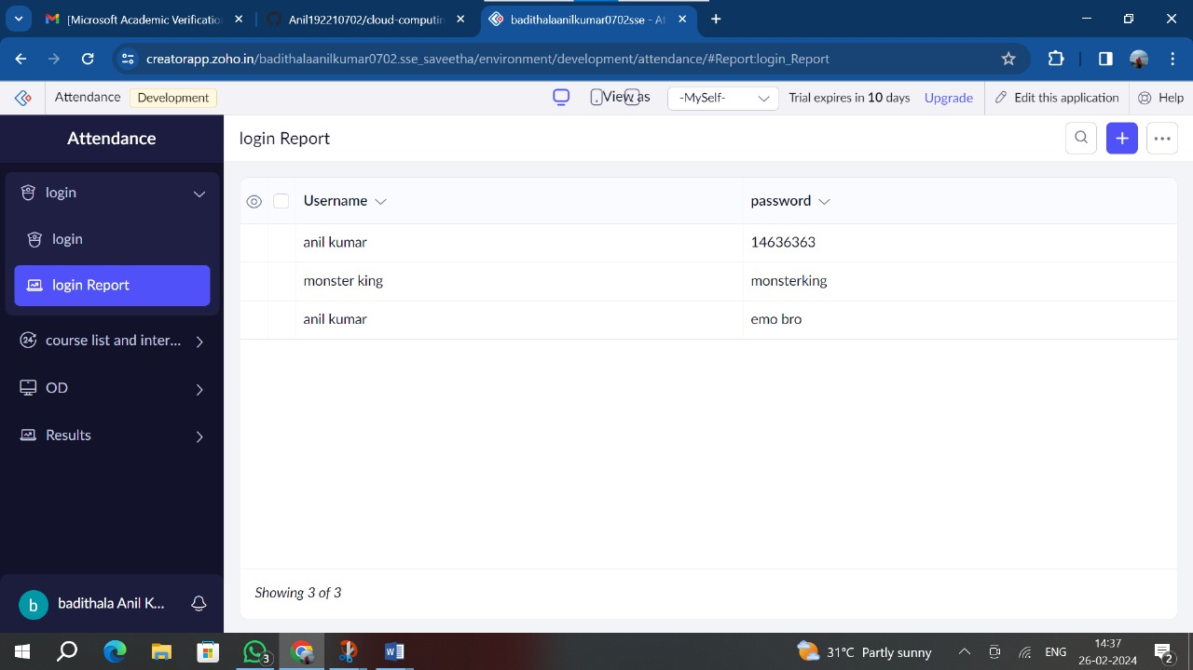

Step 10: - Click on the mobile icon to see the output in mobile format

